`Yearly Airline Performance Report` and year as 2019

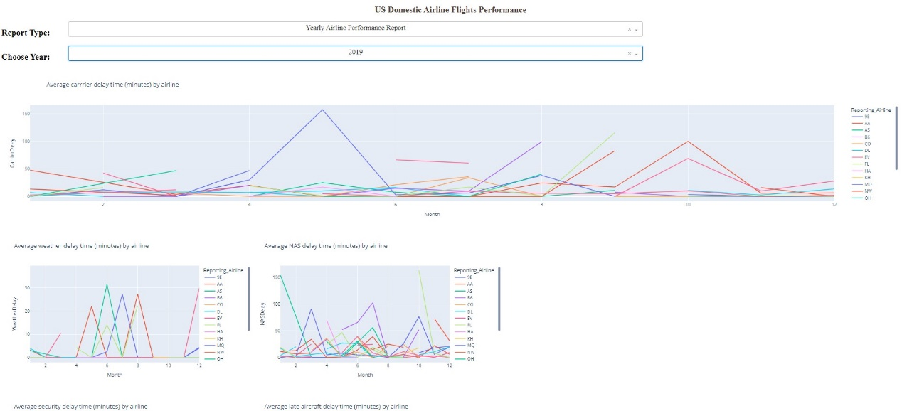

`Yearly Airline Performance Report` and year as 2015

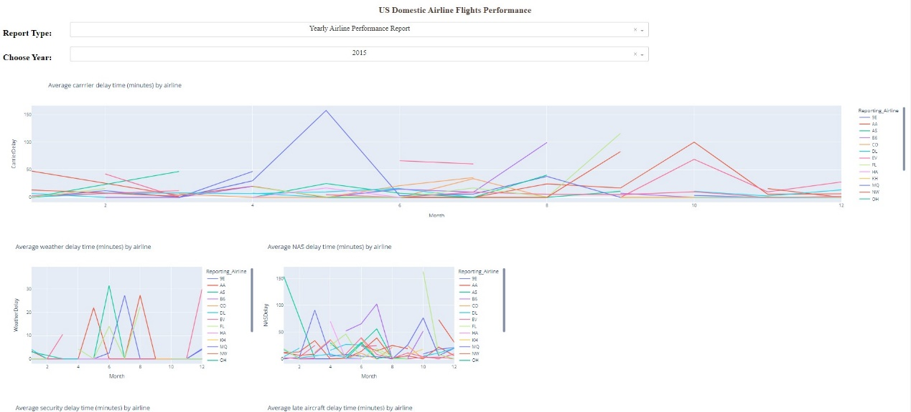

`Yearly Airline Delay Report` and year as 2019

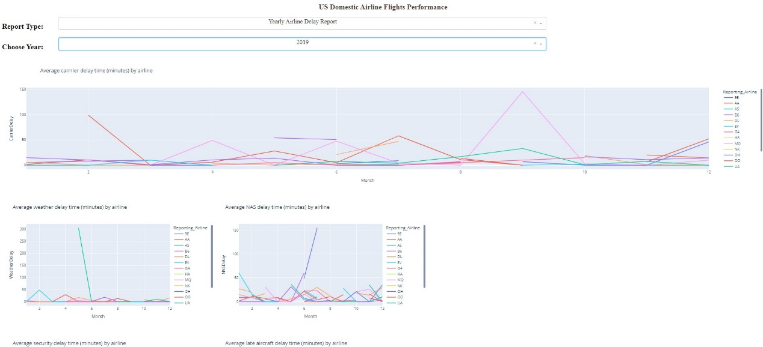

`Yearly Airline Delay Report` and year as 2008

